  - Go to blueletterbible.org
  - Look for the Multiple Verse Retrieval Section on the right side of the page under the main heading.
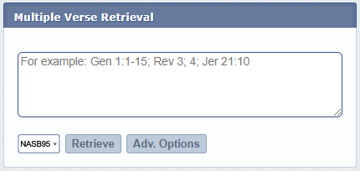

  - Click on "Adv. Options" and choose the selections below
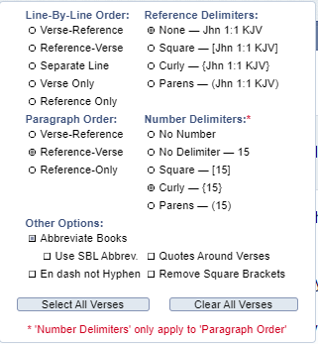

  - In the text field enter the book and chapters you want to pull. In the dropdown select the translation you want to use.
In the example below I am searching for all 28 chapters of Acts from NASB95 but only about 6 chapters will be pulled back in one go. You will need to retrieve multiple times to pull for a whole book and be careful that you retrieve all of a chapter.
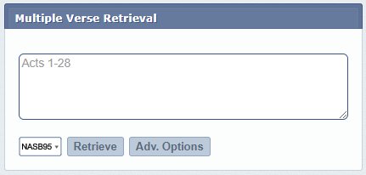

  - Hit the Retrieve button
  - The first 6 chapters of Acts are now displayed with about 7 verses of Acts 7. Select the "Copy to Clipboard" button.
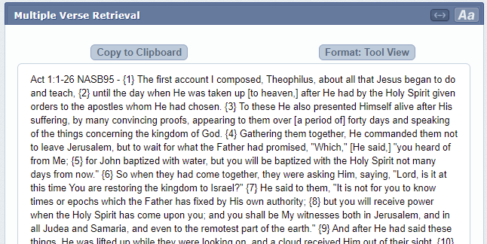

  - Paste the clipboard into a word processing document. (I am using Microsoft Word).
  - Go back and retrieve the rest of the book and paste into the document.

Great we have the text now but it's not very useable yet.
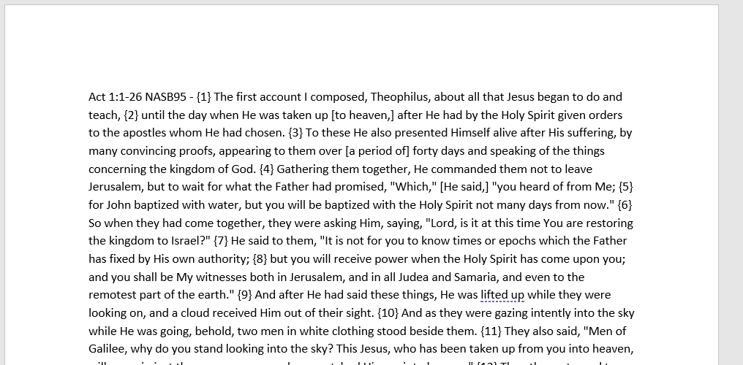

  - Open up the Find and Replace by using ctrl+h
  - In Find enter {
and in replace enter ^p

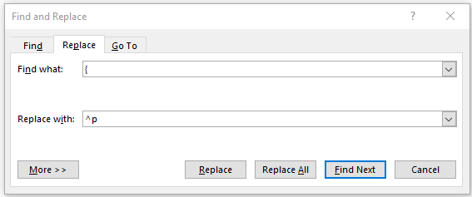

Hit Replace All and all the verses should now be on separate lines.

  - Next Replace the ending curly bracket. Again us ethe Find Replace by clicking ctrl+h
  - In Find enter }
And in replace enter a space, or . or ) or any symbol you want. You can also add a ^t for a tab if you want the text further away from the verse numbers. In the example below I am adding a . Followed by 4 spaces. (Obviously you can't see the spaces in the screenshot)
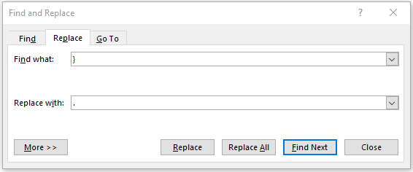

Your text should now look something like this:

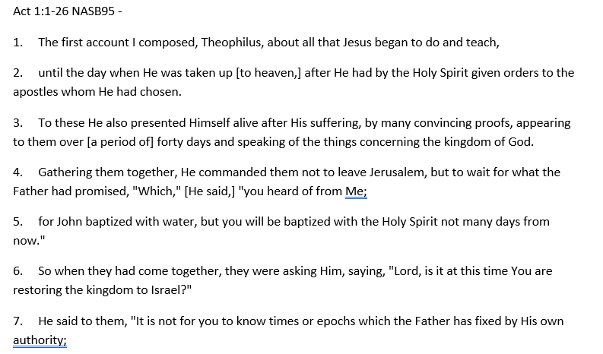

  - To indent all the text to the same spot as each first line
    - Select All the text by using Ctrl+a
    - Move the bottom triangle at the ruler at the top of the page.

Your text now should look something like this:

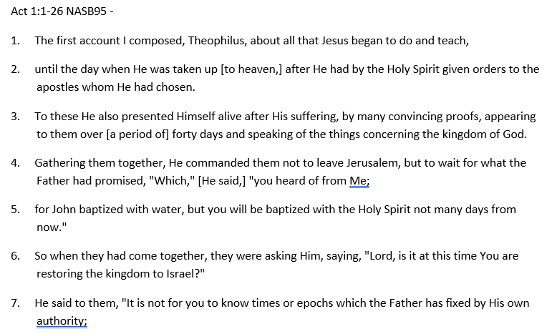

Other options
We have also found it useful to use double spacing and have page breaks for the start of each chapter.
To set the double spacing, select all the test in the document and use the line spacing option in the Home tab under Paragraph in Word.
To set a page break move to where you want to insert a page break, and under the insert tab, use the page break button.

